* Below is the example nginx.conf file.

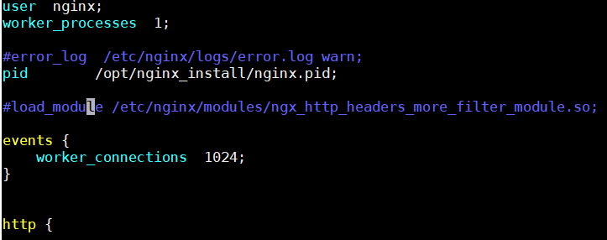

* User nginx means that the nginx is owned by the user nginx. All the nginx processes will run by that user.

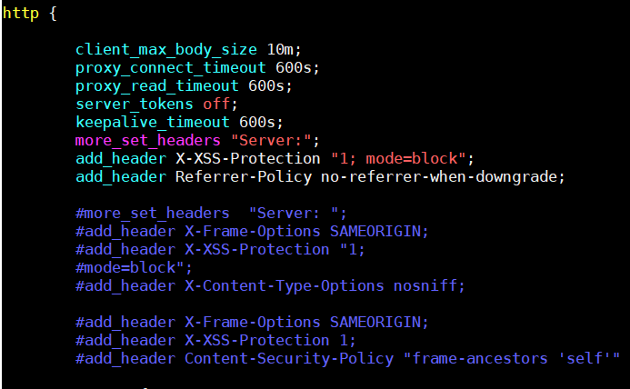

* Then under http, we configure the buffers and timeouts.

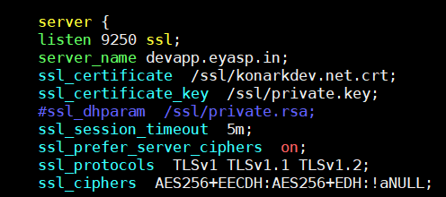

* Under server, we configure the port on which the nginx listents.
* If ssl is there, we need to give that as well with the path of certificate and key
* Also, the DNS name as server_name.

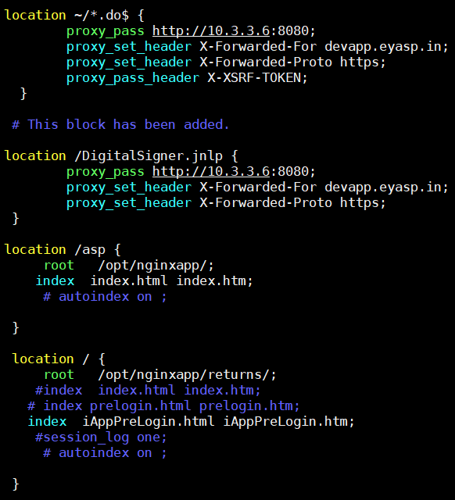

* As above, if we hit the URL with “/” and login, then it will redirect to prelogin page with ‘prelogin.html” file.
* After that when we select the app which we want to go into as below.



* When we sign out, It will take us to *.do file as we have already defined that location in config file as above.

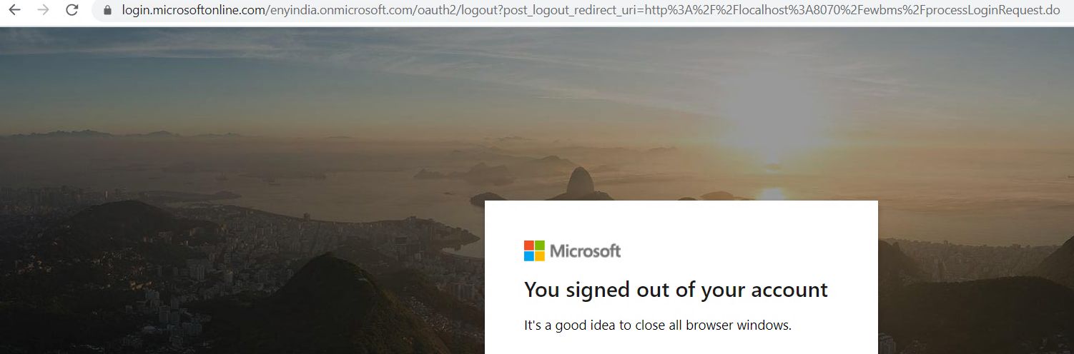

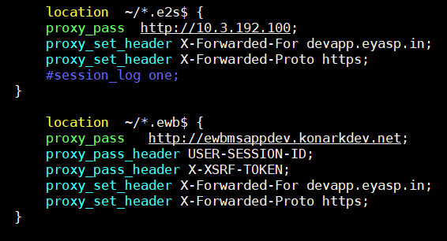

* The same way we can configure for backend Kubernetes also
* As above, the http URL and http DNS are the ingress layer configurations from Kubernetes.

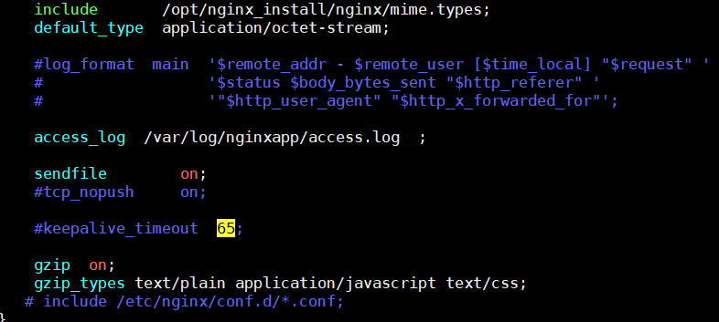

* At the end, we finally can give the mime types inclusion, access log path and gzip on etc as above.

**Include:**

* We can include the files in nginx conf file as below.

